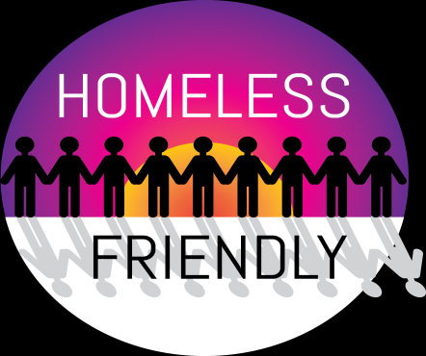
(Due to Covid restrictions please check operating hours)
South Manchester Emmaus
Dandelion
We are an inclusive radical church in South Manchester and hold drop in Sundays in Wythenshawe 11-12.30midday and Wednesdays 11am-2pm.
We are working with Emmaus, Food cycle and local and national organisations to reduce hunger, homelessness and climate change. The Dandelion Community is at the corner of Oatlands Road where it joins with Portway. Postcode: M22 1AH and M22 6AH

Emmaus – South Manchester
The emporium is open Thursday to Saturday 10am – 4pm, also housing a community café offering a friendly listening ear and are able to sign post to local services. Tel 0161 769 955 for more information. We are based at Saint Andrews church Brownley Rd, Wythenshawe M22 0DW

Sanctuary Scheme
If you are in an abusive relationship your safety and security is of utmost importance. The Sanctuary Scheme, as it is known, is a way of helping you feel safe in your own home.
The scheme is a result of the partnership formed between WCHG, along with other housing associations in Manchester, and the Greater Manchester Police to help victims of domestic abuse.
What is it?
The Sanctuary Scheme is offered to people who are worried about their personal safety and can help by adding security measures to their property. This ensures that the tenant feels secure enough to remain in their homes.
Designed to your needs Each security package is individually designed to meet the needs of each person and the Group has a designated champion to support residents through the scheme and beyond.
The different levels of security measures offered can be anything from an anti-arson letterbox to a Sanctuary Room (also known as a Safe Room). The main bedroom is often used for this purpose; the door is replaced with a solid core door which is fitted with steel hinges, bolts and a door viewer.
A home link alarm is fitted by the police as standard to a full Sanctuary Room. Additional security measures that can also be provided include extra locks, window grilles and gates.
If you feel you could benefit from the Sanctuary Scheme please contact either: Simon Melloy or Bernie Woodward on 0161 946 7518, Bernie.woodward@wchg.org.uk.

The Young People’s Support Foundation (YPSF) helps young people in Manchester to live independently.
If you’re aged 14 to 25 and homeless, worried about being homeless, or just need some impartial advice on what you can do next, we can help.
We provide advice and support to all young people, regardless of where you’re from or what your background is.
We won’t turn you away if you have a history of offending, if you have problems with substance abuse, or if you’re worried that you’re not entitled to help and support – whatever the reason may be.
We’re completely impartial and will never judge you. If we can’t help you, we will help you to find the support you need.
The help and support we offer is free and confidential.
To find out more about how we can help, call us at City Centre Project on 0161 228 7654 or if you live in Wythenshawe contact Signpost on 0161 436 5432.

Tree of Life Centre Wythenshawe
Tree of Life is a centre for health and well-being, responding to the needs of the community and building resilience, independence and minimising social isolation. They provide a number of services such as an IT learning centre, a job club, health and wellbeing classes, a community café, and a foodbank. They also have a supported volunteering programme that helps Manchester residents to build skills and experience.
Proposed activities They want to continue to develop the services they offer, such as their volunteering and the health and wellbeing programmes, and their community café.
They primarily work with residents in South Manchester, such as Wythenshawe, Woodhouse Park, and Baguley
Website www.treeoflifecentre.org.uk
The Tree of Life Centre, Greenbrow Road, Wythenshawe, Manchester, M23 2UE

Reach out to the Community (work within Wythenshawe)
Carry out support and outreach work on the streets and run a charity shop on Wilbraham Road, Chorlton plus run a food bank, which gives non-perishable food, toiletries and other items to individuals and families referred to us by other organisations. Print or save our handy shopping list.
Responding to client needs: if someone is in need, we’ll give food, a hot drink or warm dry, clothing. We also make appointments, help sort out personal admin (such as registering with a doctor), give advice, make referrals to other agencies, help with benefits or housing applications, or cover travel costs. If someone doesn’t read or write, we’ll read paperwork for them or help with forms; if someone doesn’t have access to a computer (and who on the street does??), they can use ours – on their own, or we’ll work together.
Reach Out to the Community Charity Shop & Community Hub, 488 Wilbraham Road, Chorlton, M21 9AS - We’re open Monday-Saturday 10am-4.30pm. Tel: 0161 862 9415

Street Support Information
Please also ask the person if they are familiar with Street Support www.streetsupport.net This website is for homeless people and professionals and explains where all the local services are across Greater Manchester.
There is also a Street Support App which can be down loaded to smart phones

